**Project Report**

|  |  |
| --- | --- |
| **Project Title** | Predictive Analysis using Machine Learning Models |
| **Module Name** | WSQ Principles of machine learning (SF) |
| **Qualification Name** | Advanced Certificate in Data Science (E-Learning) |

|  |  |  |  |
| --- | --- | --- | --- |
| **Student name** |  |  | **Assessor name** |
| Toh Yi Ting |  |  |  |
| **Date issued** | **Completion date** | | **Submitted on** |
| 23 February 2024 | 6 March 2024 | | 6 March 2024 |
|  |  |  | |
| **Project Title** | Predictive Analysis using Machine Learning Models | | |

|  |
| --- |
| **Learner declaration** |
|  |
| I certify that the work submitted for this assignment is my own and research sources are fully acknowledged.        Student signature: Date: 23 February 2024 |

**Content**

|  |  |  |
| --- | --- | --- |
| **Sr. No.** | **Description** | **Page No.** |
| 1 | Project Overview | 3 |
| 2 | Project Technical Environment | 4 |
| 3 | Analytical Technique & Tools used | 5 |
| 4 | Data Science Project Team – Roles and Responsibilities Table | 6 |
| 5 | Activity 1: Activity Summary | 7 |
| 6 | Activity 2: An Overview | 8 |
| 7 | Screenshots of each task of Activity 3 | 9-12 |
| 8 | Screenshots of each task of Activity 4 | 13-16 |
| 9 | Screenshots of each task of Activity 5 | 17-20 |
| 10 | Screenshots of each task of Activity 6 | 21-24 |
| 11 | Screenshots of each task of Activity 7 | 25 |
| 12 | Conclusions and Future Improvements | 26 |
| 10 | Appendices   1. Code Snippets and Configurations 2. Additional Visualizations / Screenshots | 27 |

1. **Project Overview**

In this project, I will look into the OKCupid dataset, a rich source of information about individuals' preferences, lifestyle choices, and personal attributes.

The primary objective is to conduct a series of tasks encompassing data loading, exploration, cleaning, and preparation, followed by the application of machine learning models for predictive analysis in three distinct areas: Zodiac sign prediction, body type prediction, and income prediction.

Additionally, I will engage in a sex prediction task based on education level and income.

1. **Project Technical Environment**

ABC Analytics has undertaken a comprehensive project focused on leveraging predictive analytics on OKCupid data to extract valuable insights. The objective is to enhance the understanding of user behaviour and preferences within the OKCupid platform.

Data will be processed in a Jupyter notebook with the use of Python libraries.

1. **Analytical Technique & Tools used**
2. Pandas
3. Numpy
4. Matplotlib
5. Seabons
6. Scikitlearn

For Model Building:

1. Logistic Regression
2. Random Forest
3. Decision Tree
4. SVC
5. ANN
6. **Data Science Project Team – Roles and Responsibilities**
7. Downloading the dataset and preparing it for analysis.
8. Clean the dataset before model building.
9. Build models for predictions.
10. Evaluate performance of models and draw conclusions.
11. **Activity 1: Activity Summary**

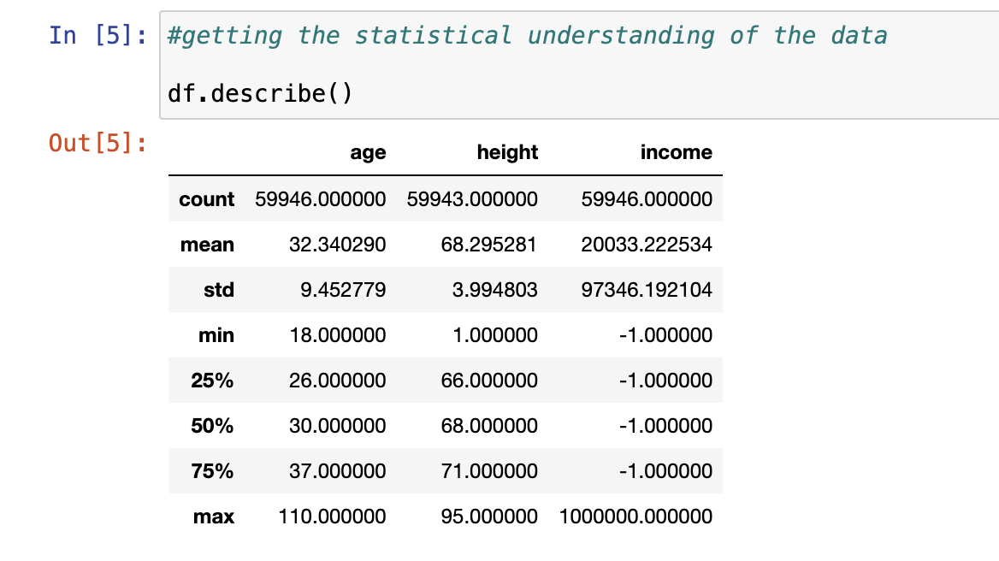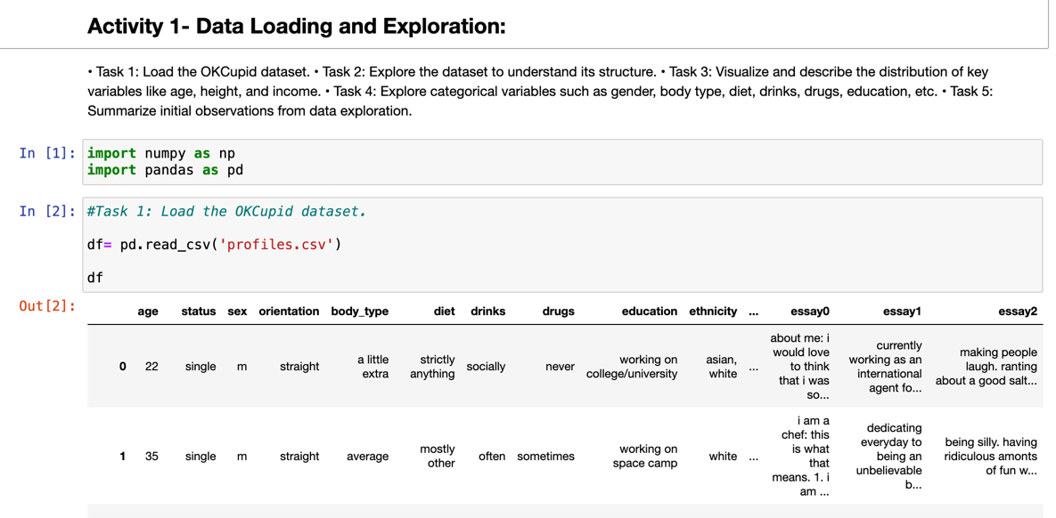

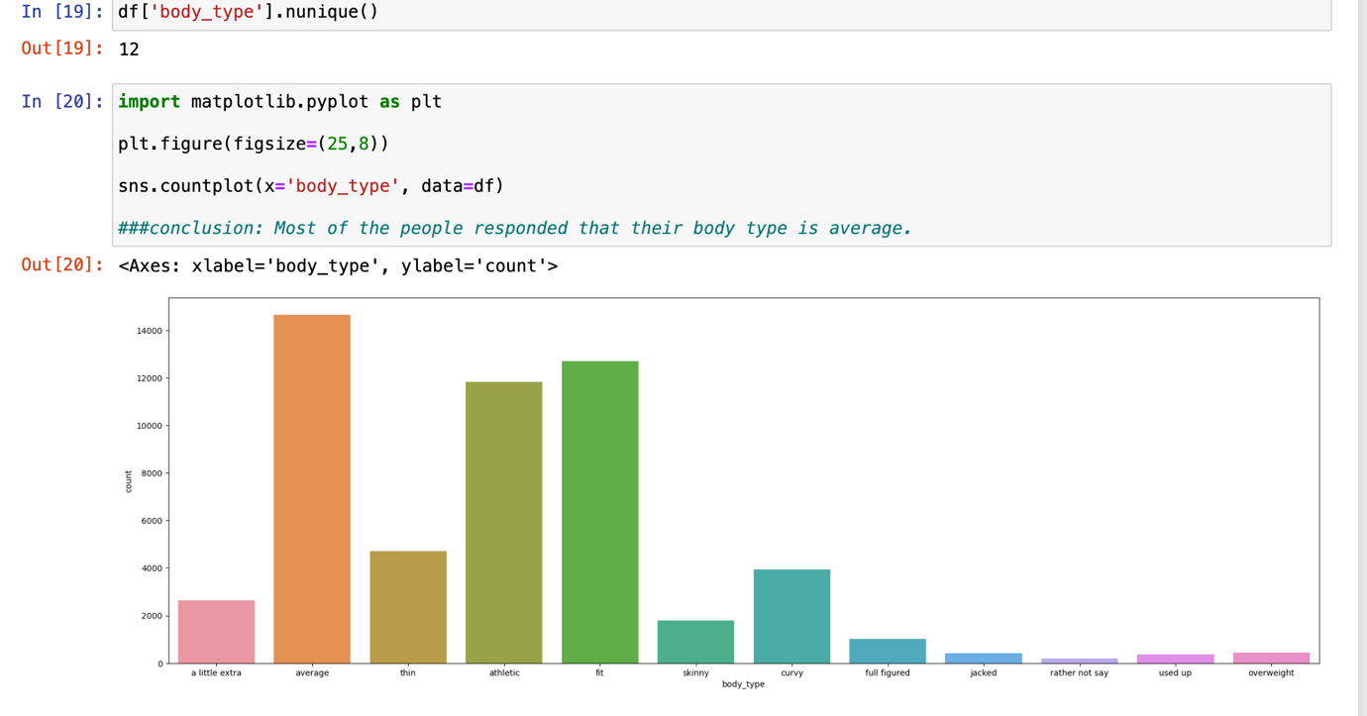

1. **Activity 2: An Overview**

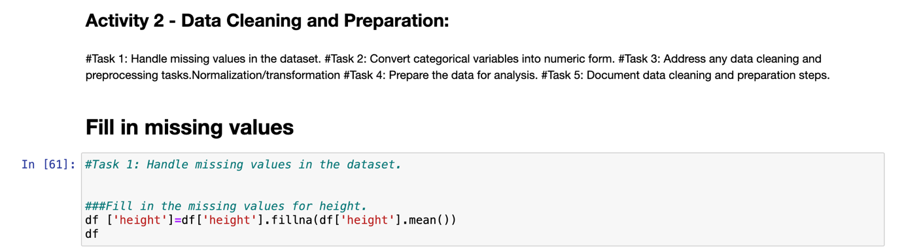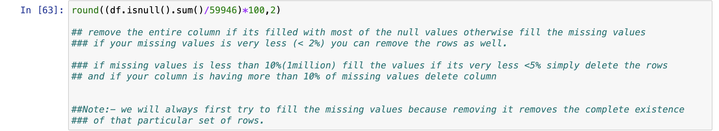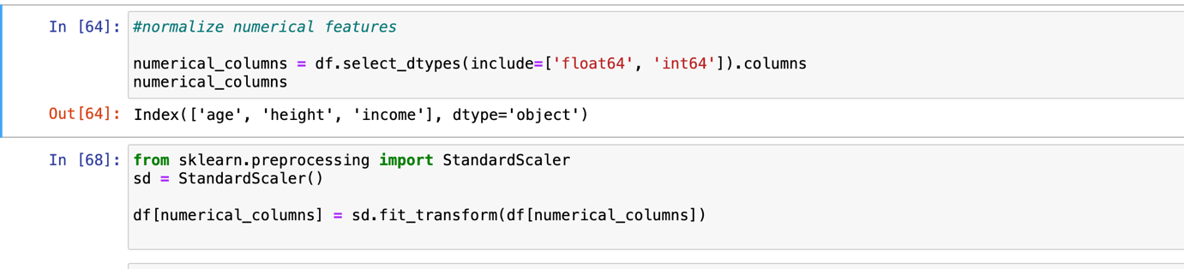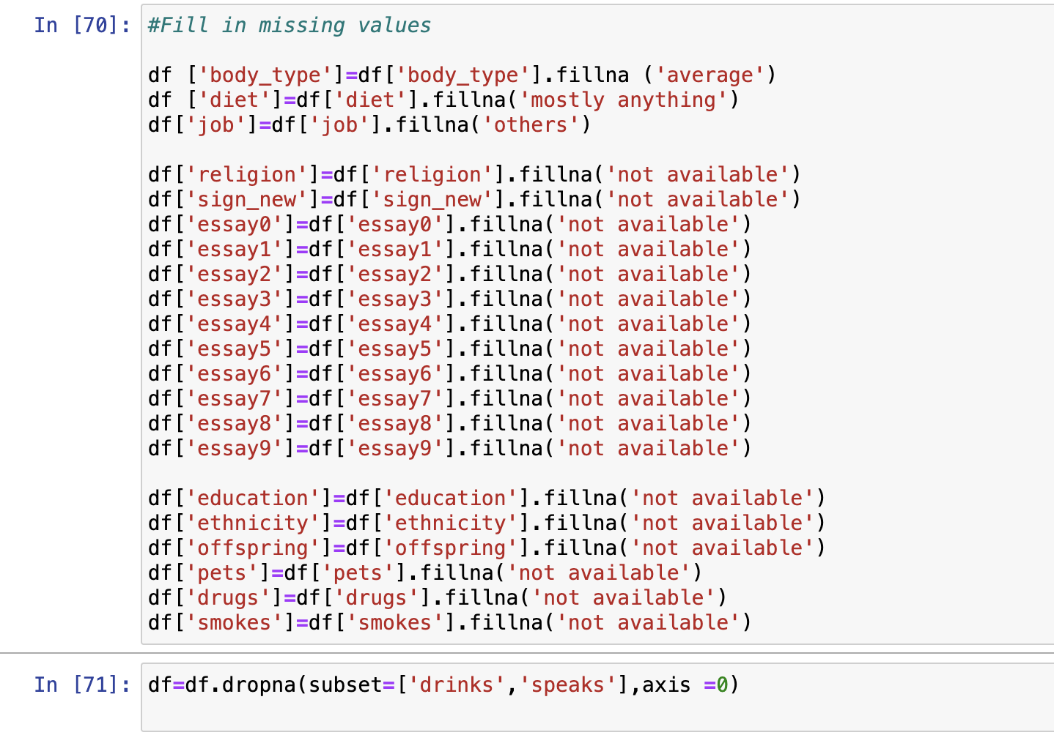

1. **Screenshots of each task of Activity 3**

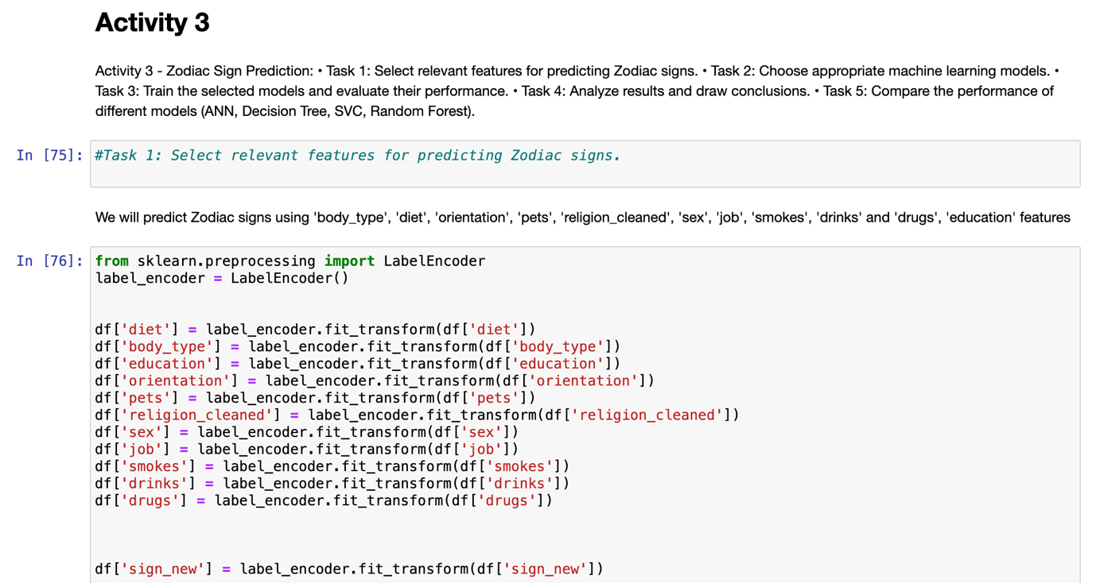

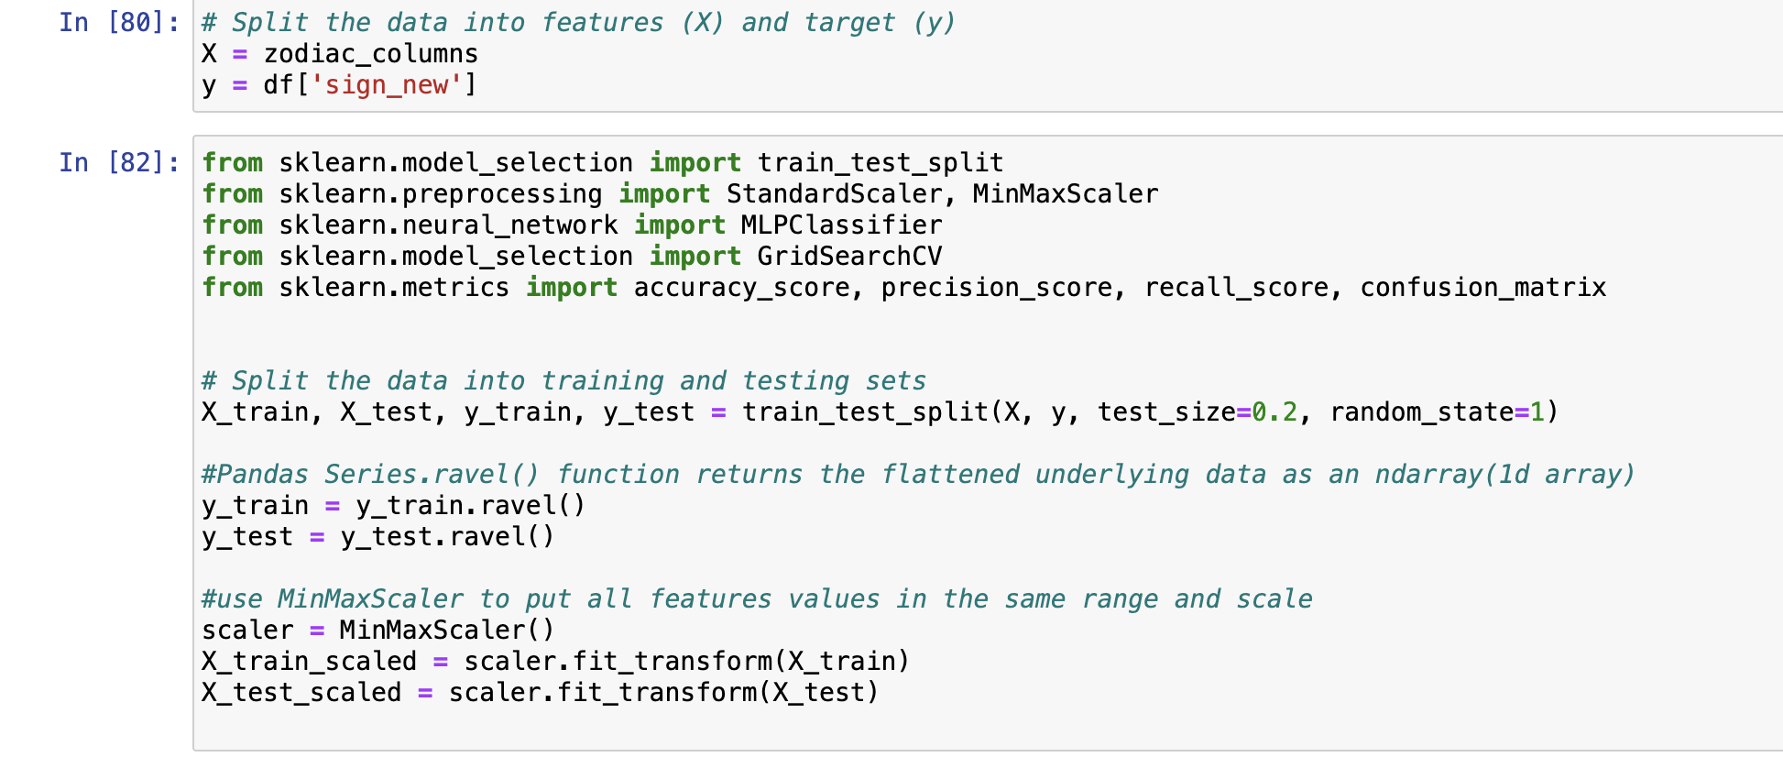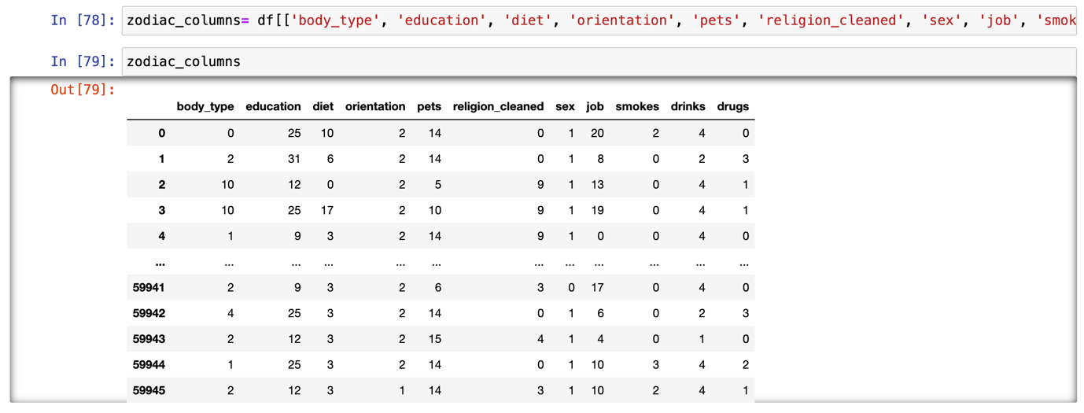

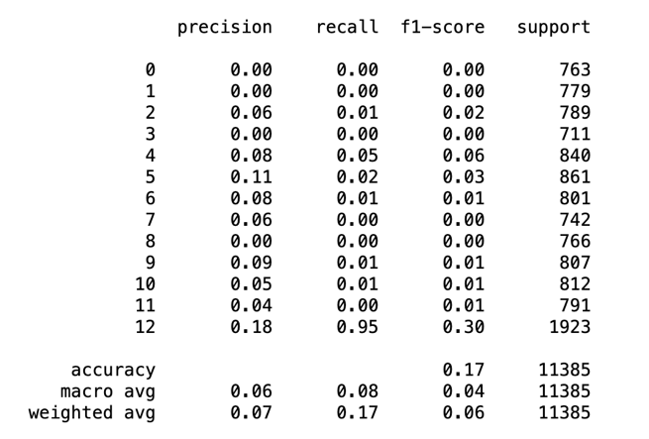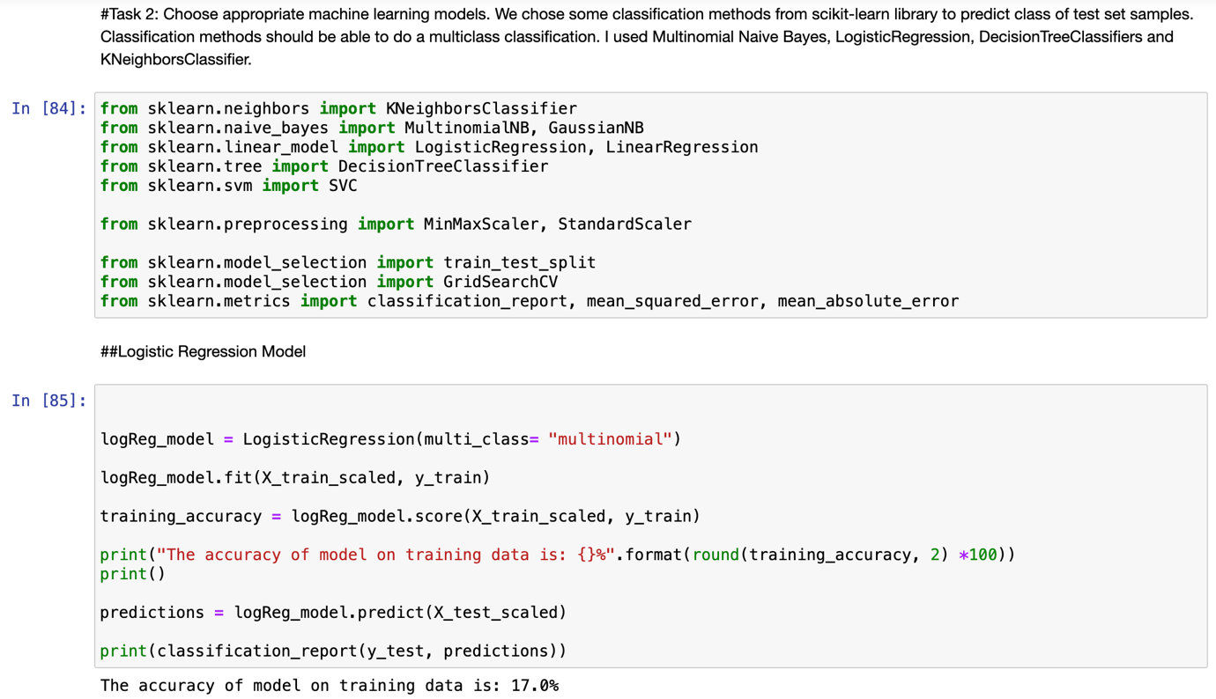

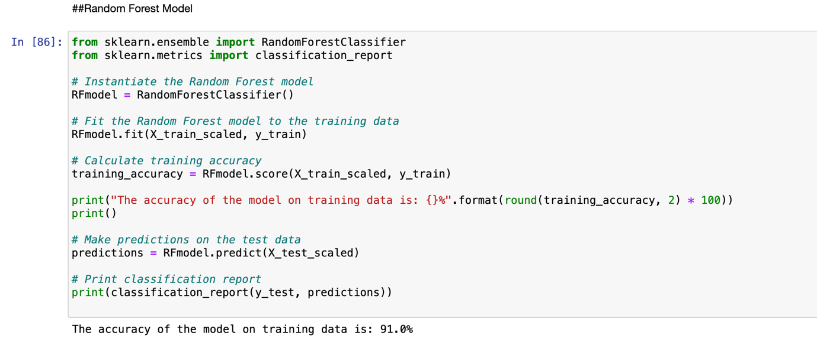

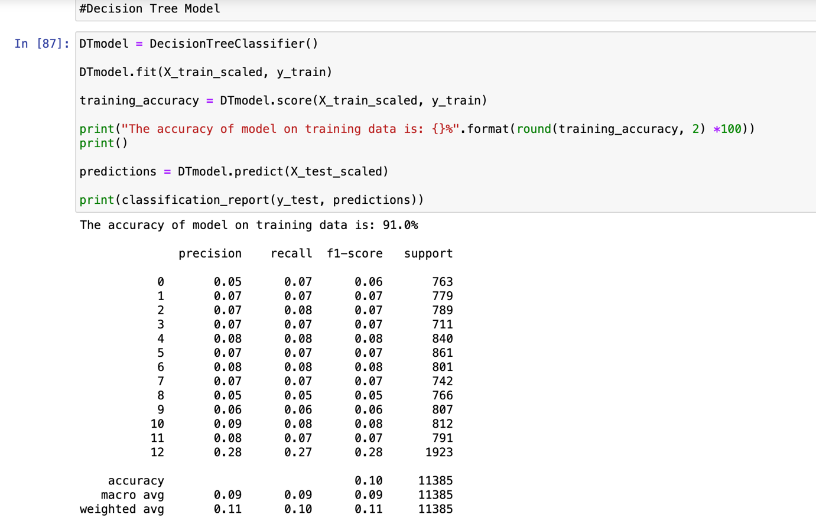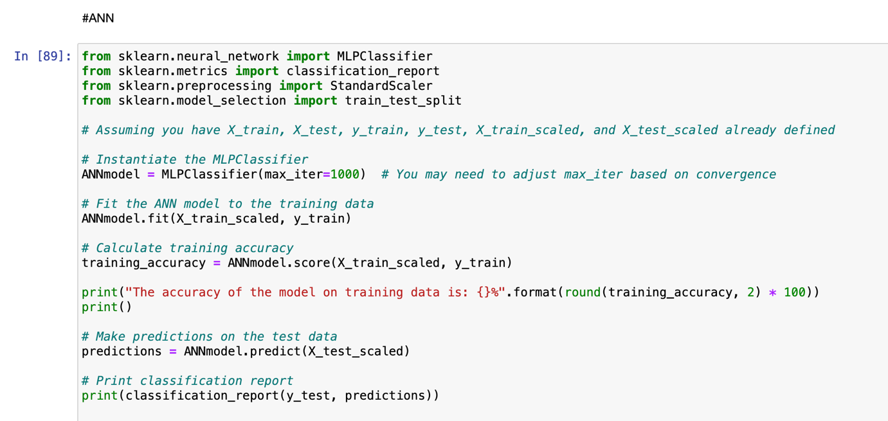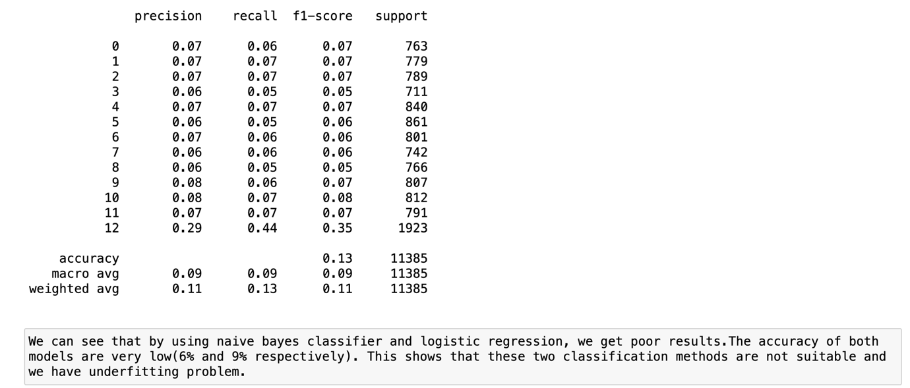

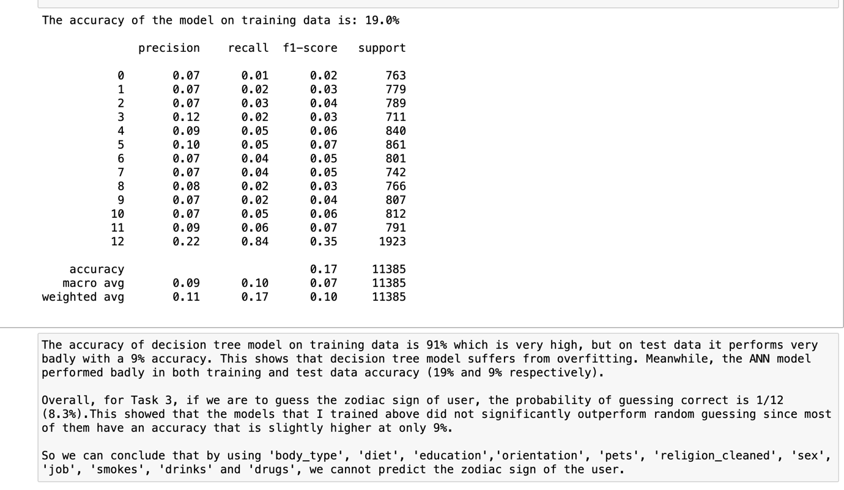

1. **Screenshots of each task of Activity 4**

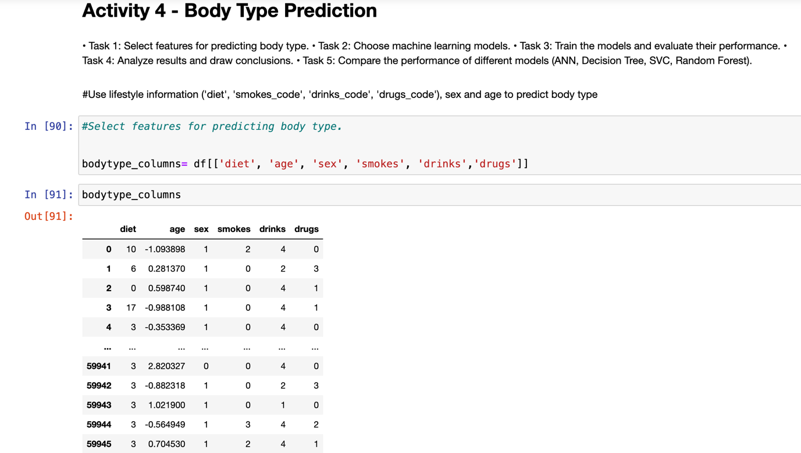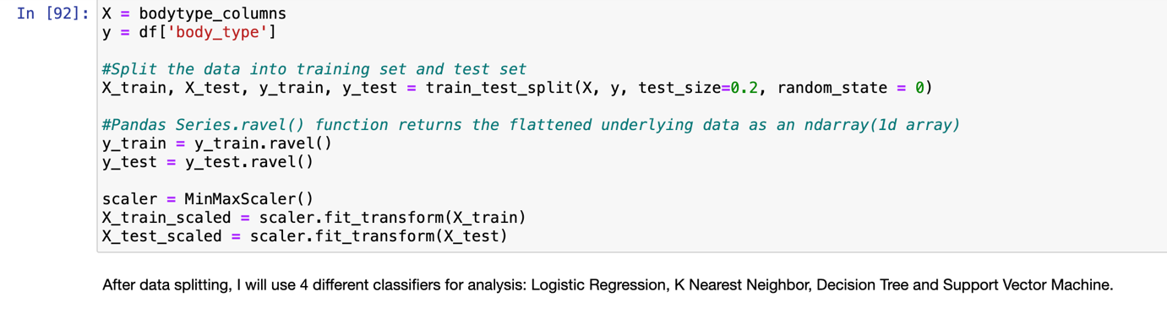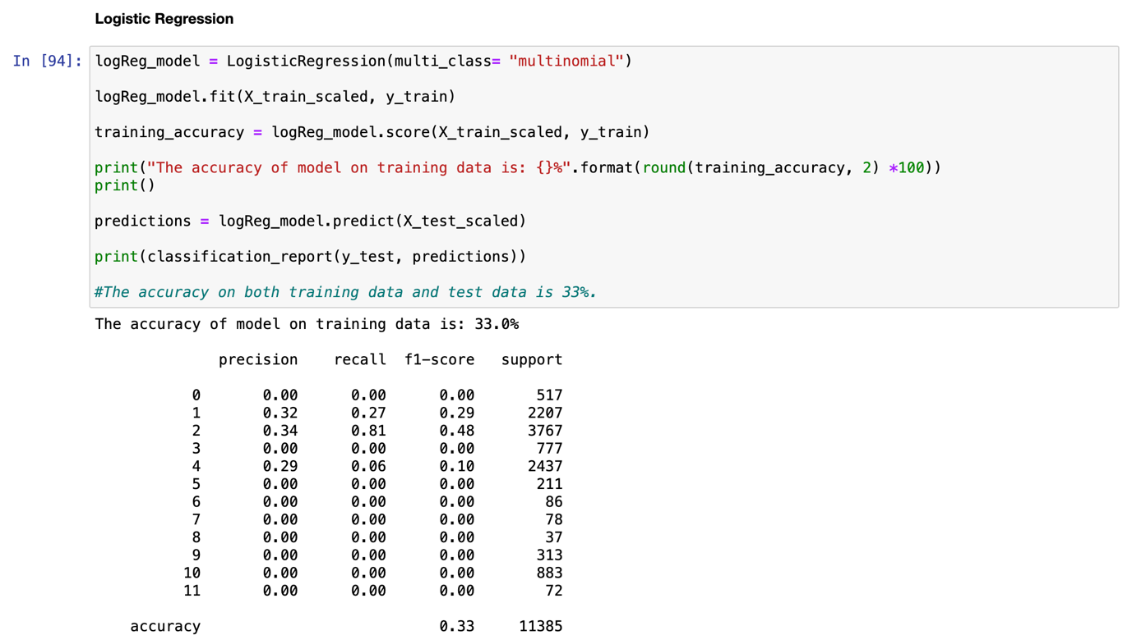

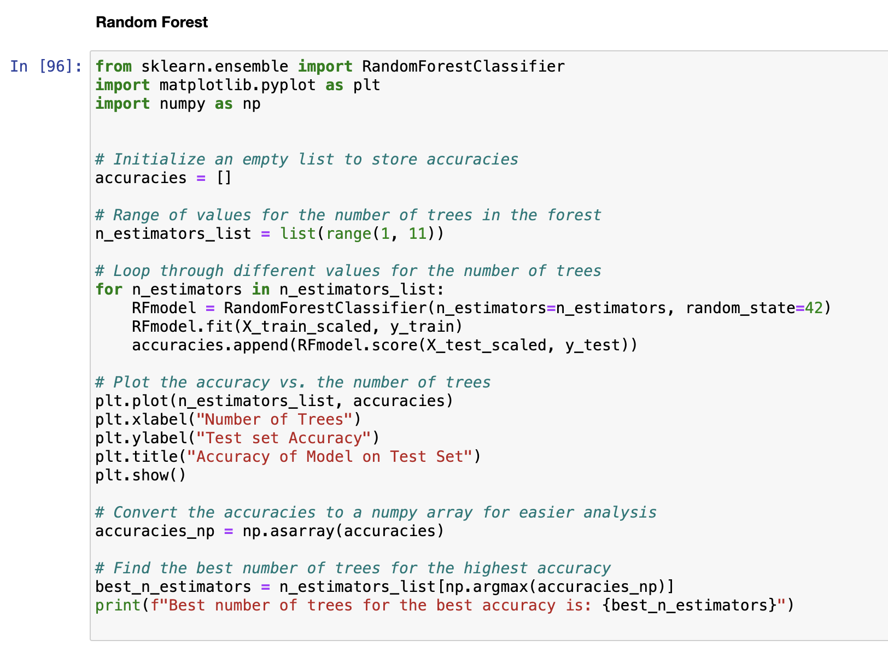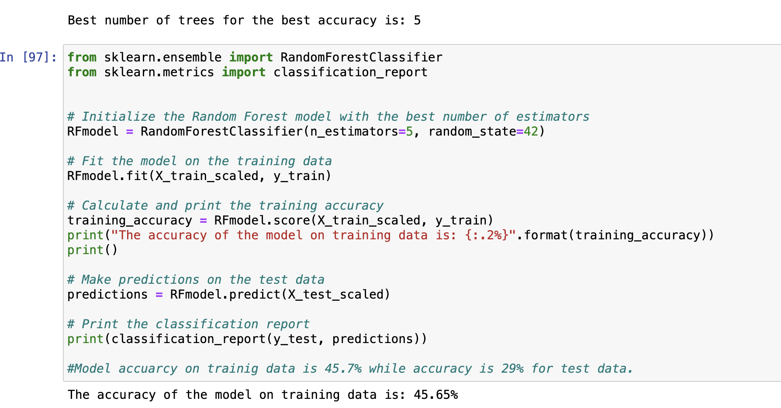

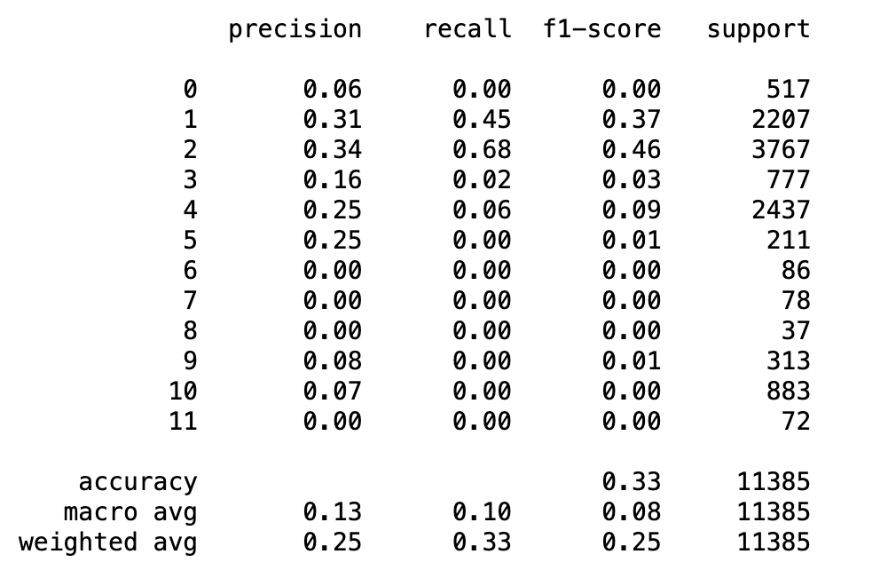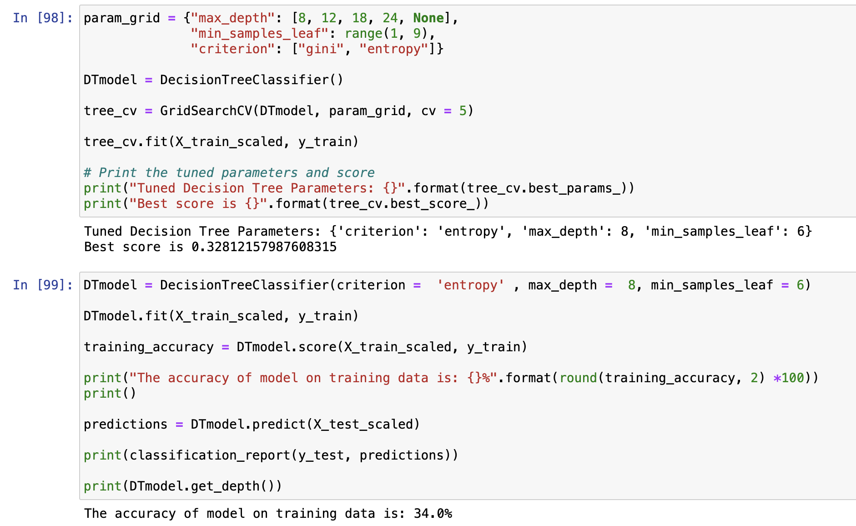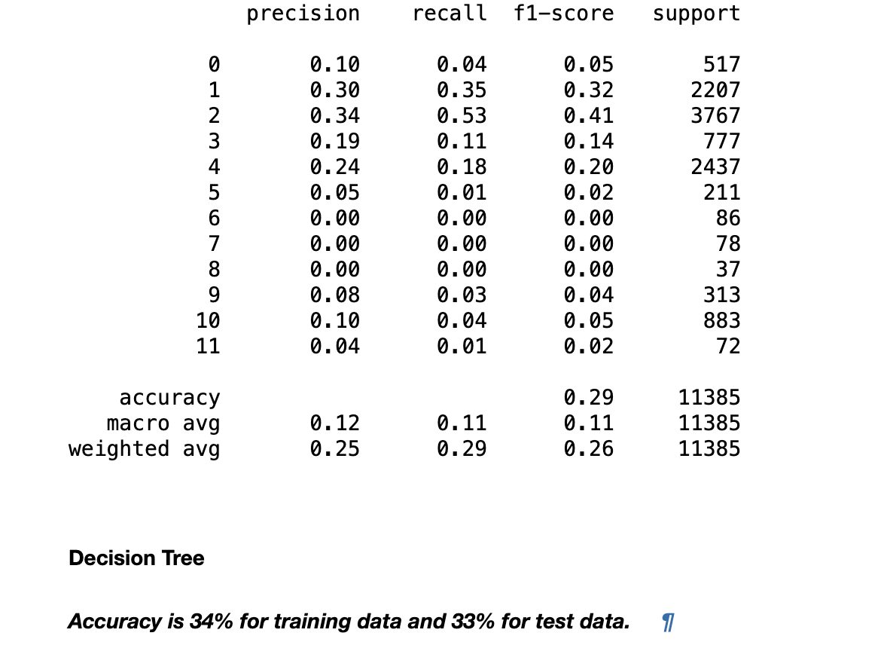

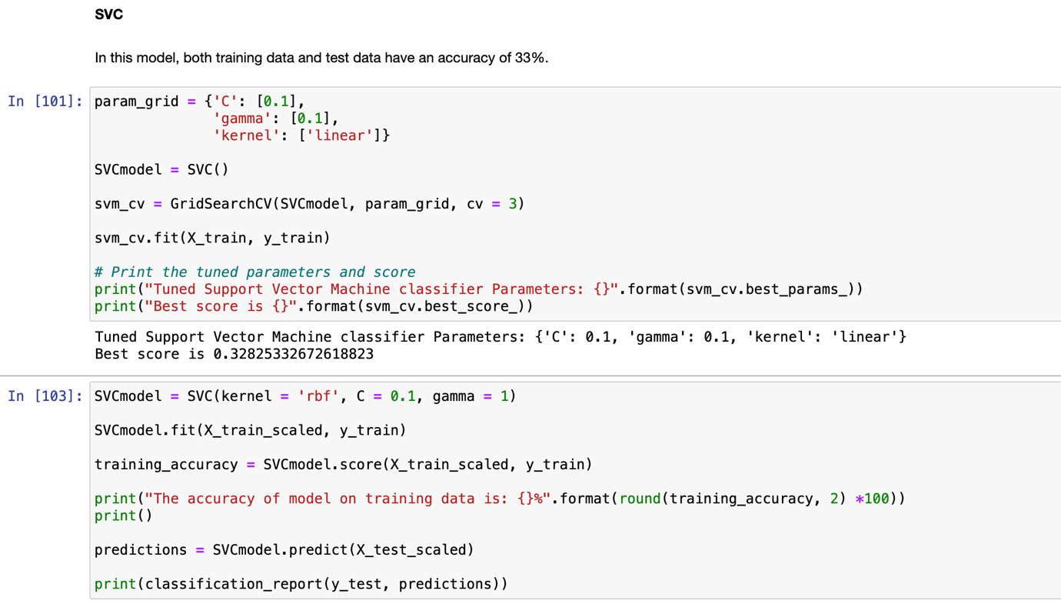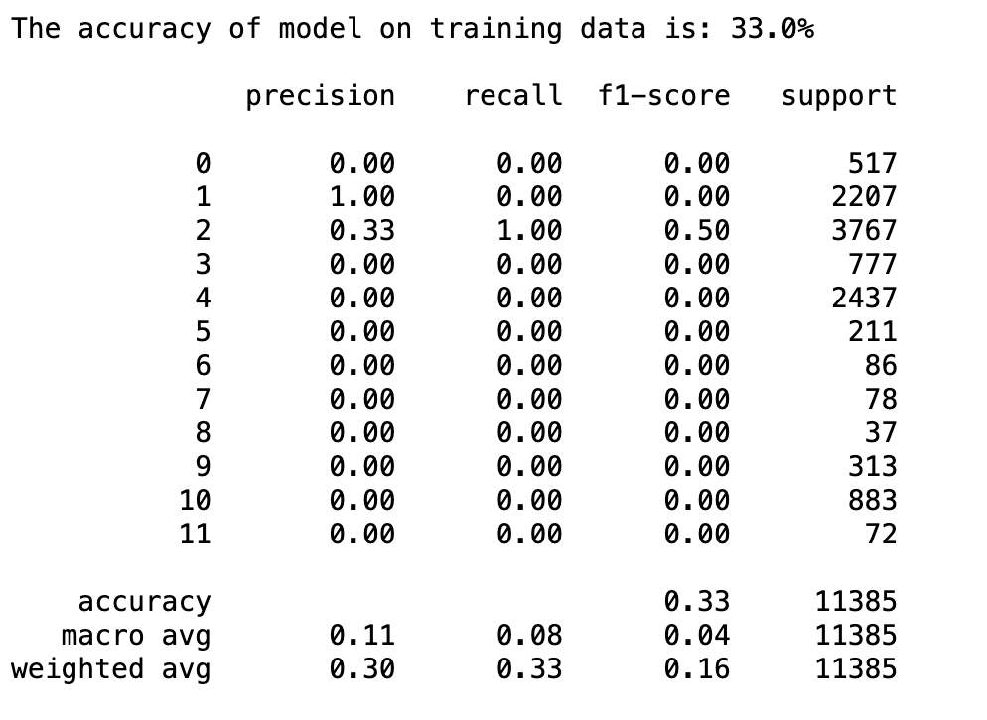

1. **Screenshots of each task of Activity 5**

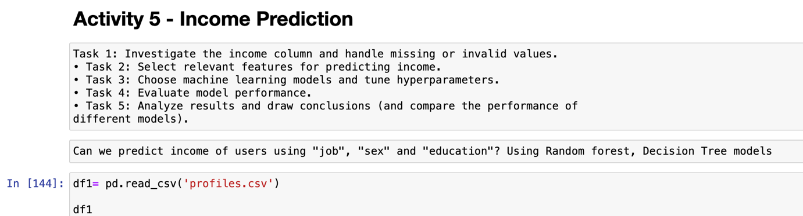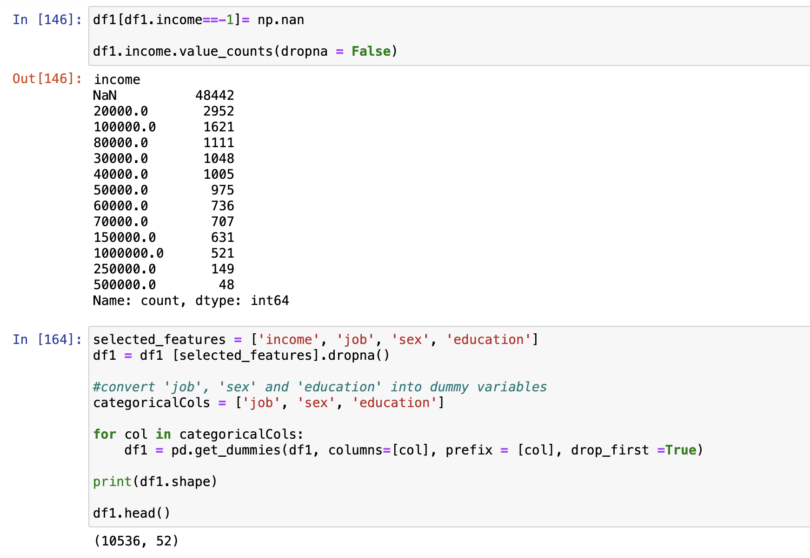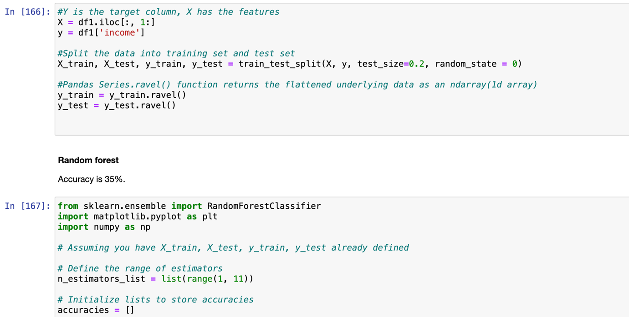

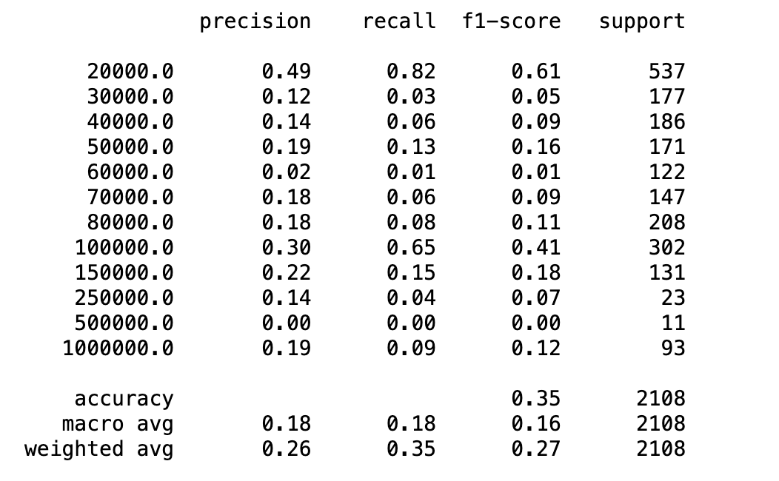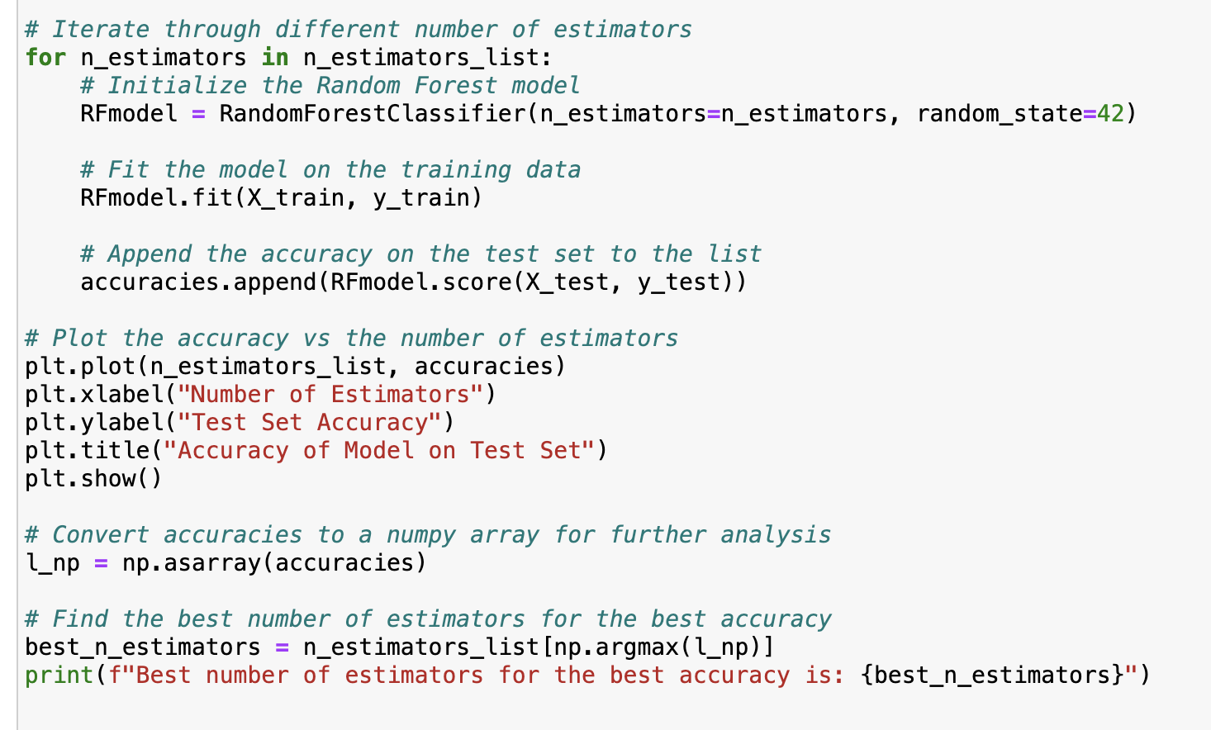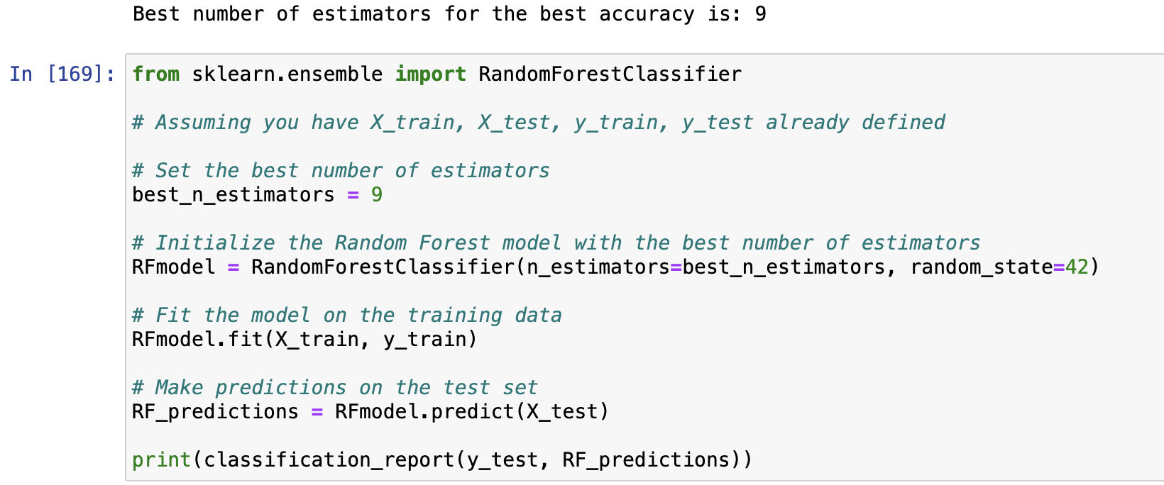

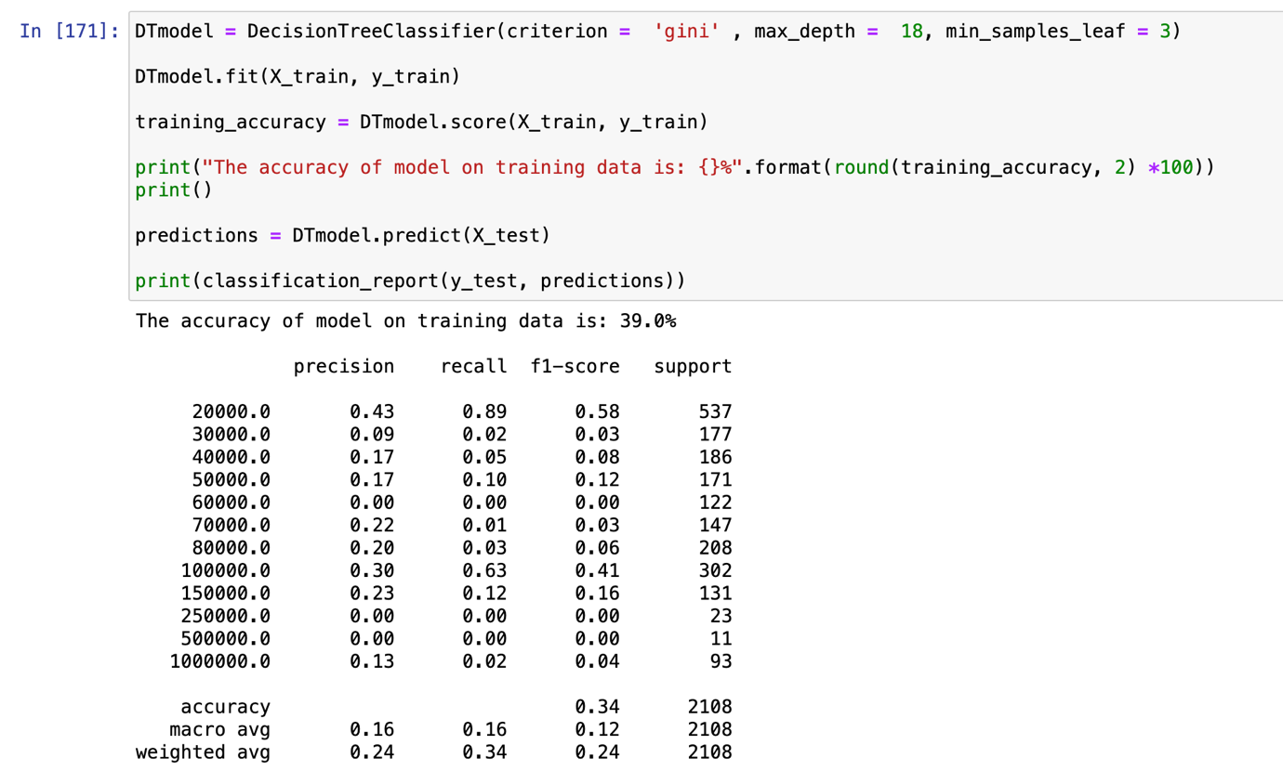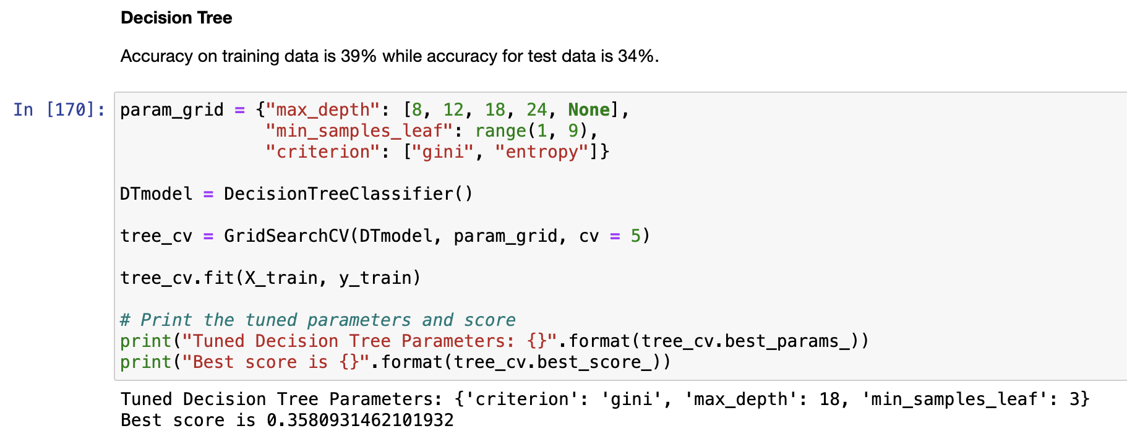

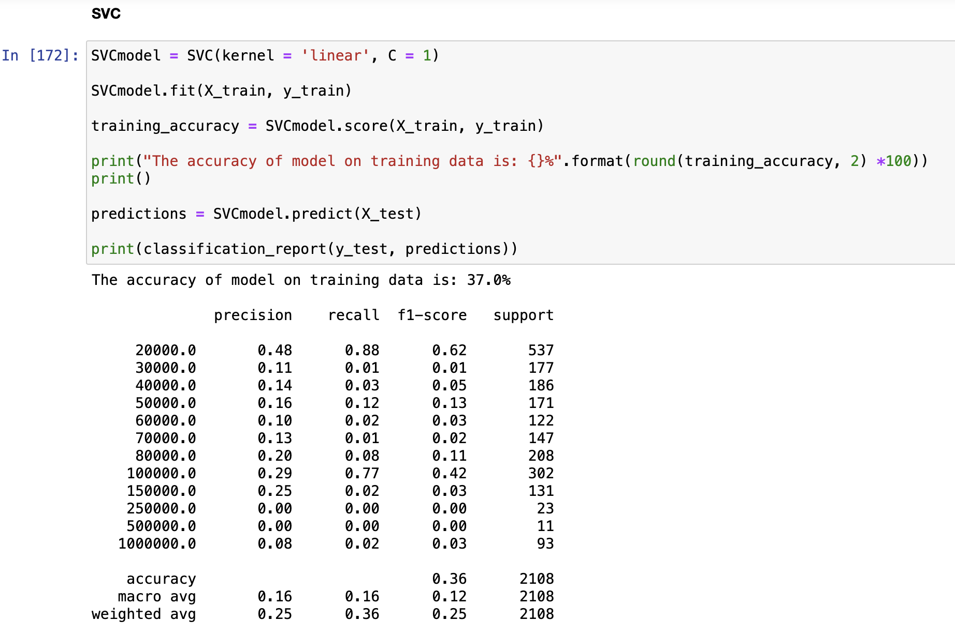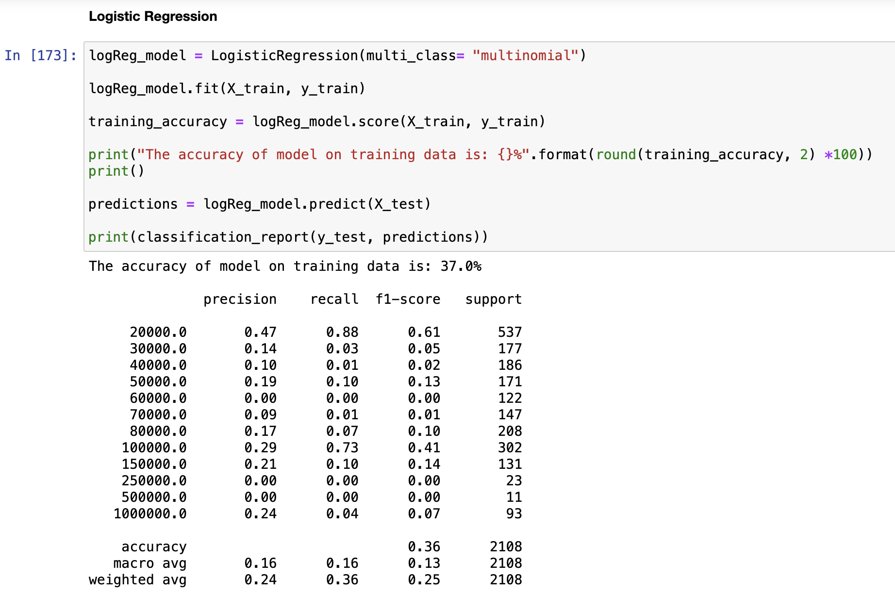

1. **Screenshots of each task of Activity 6**

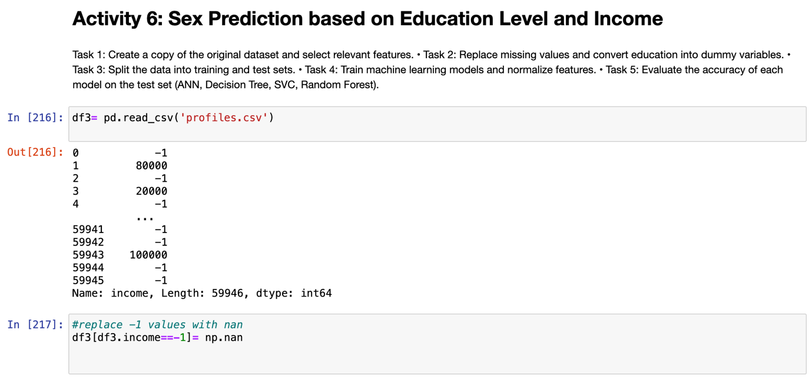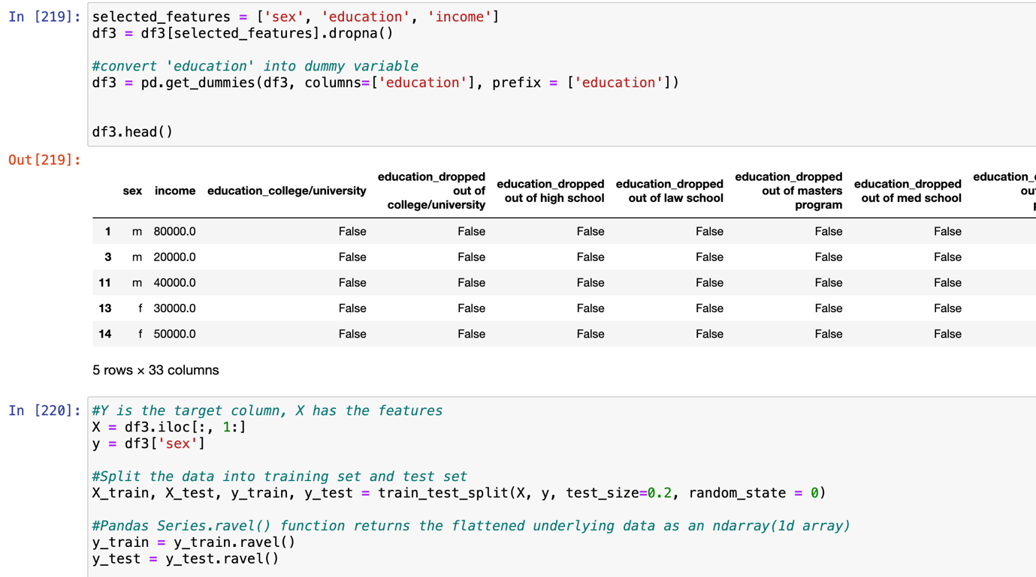

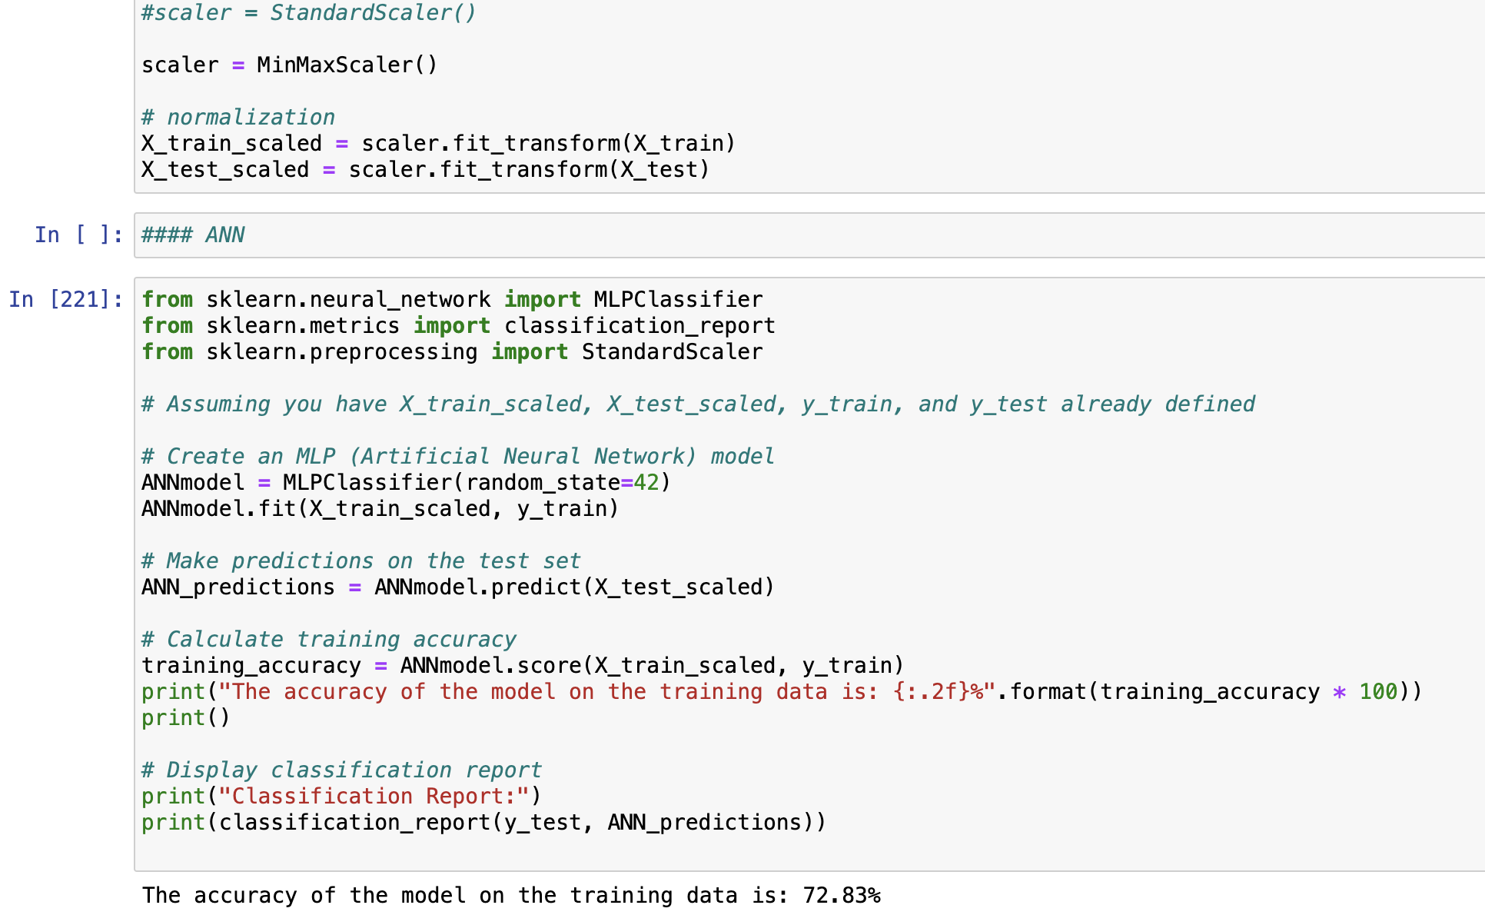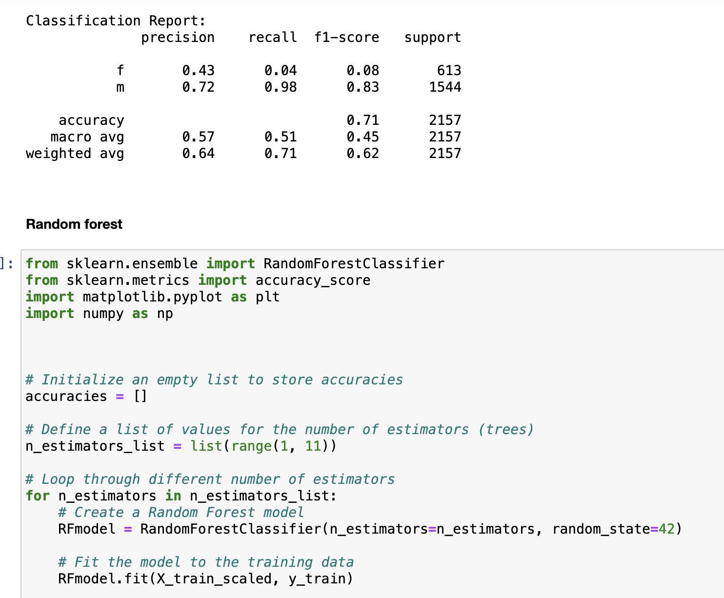

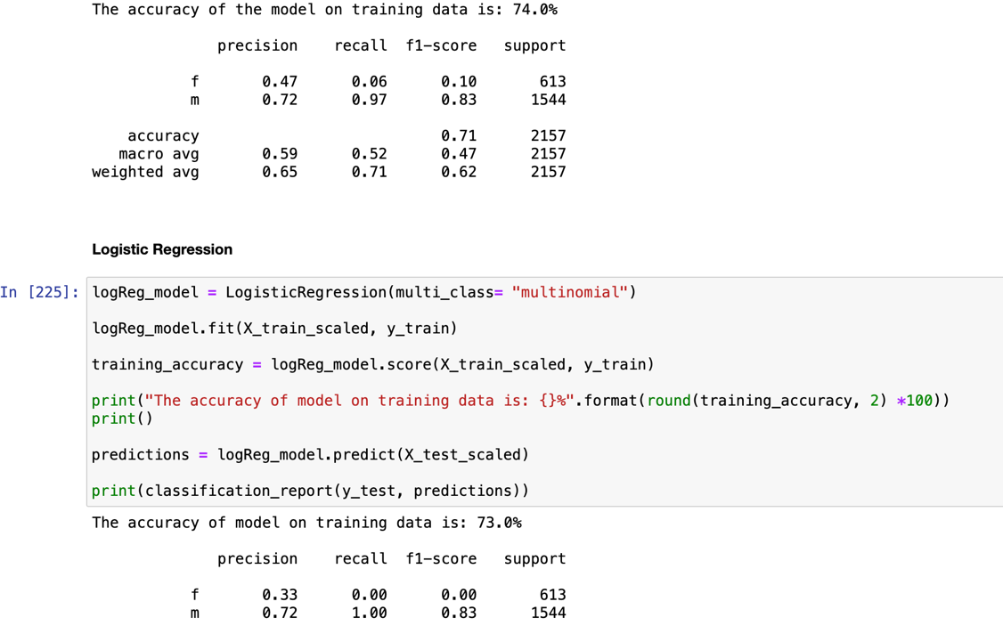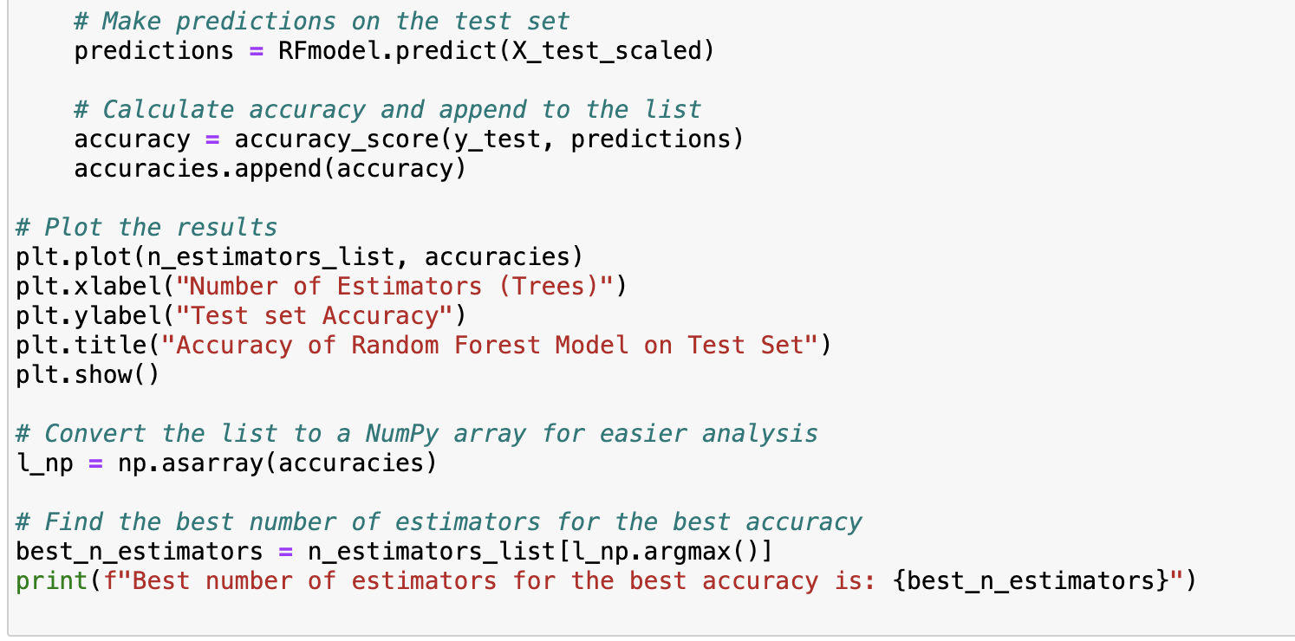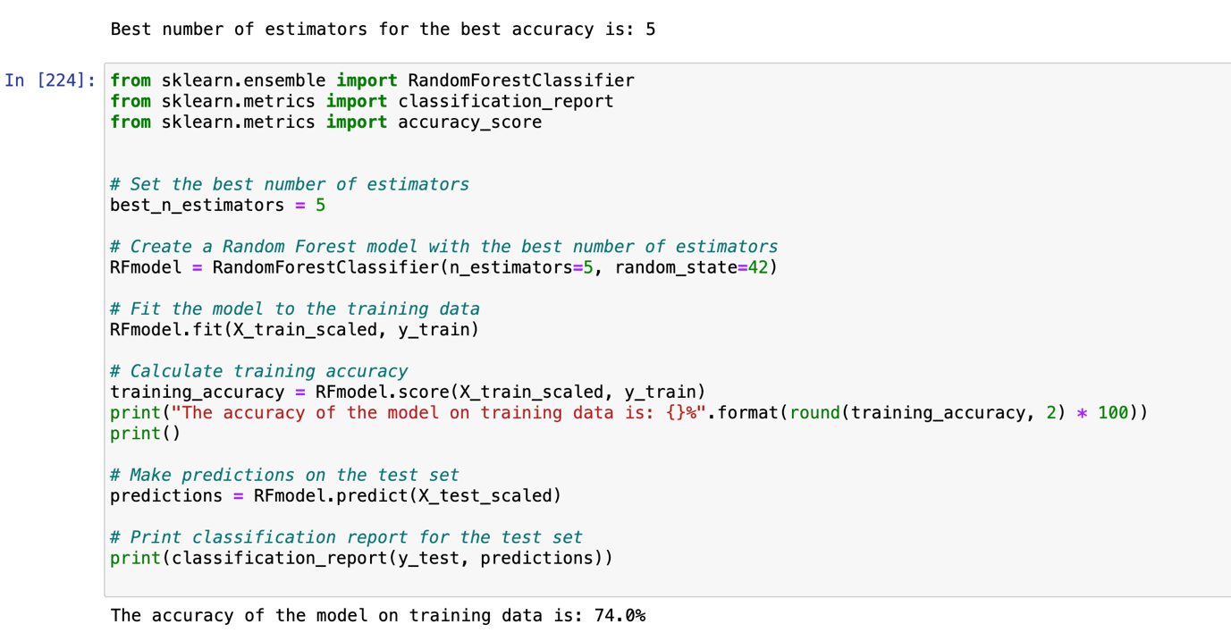

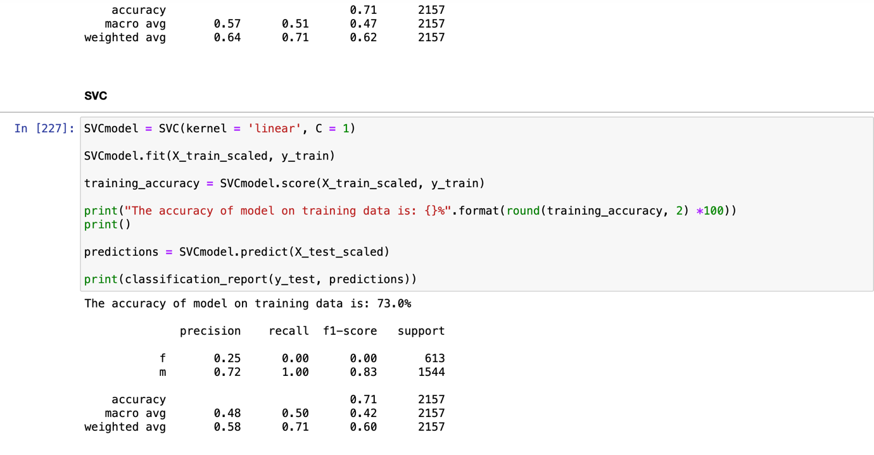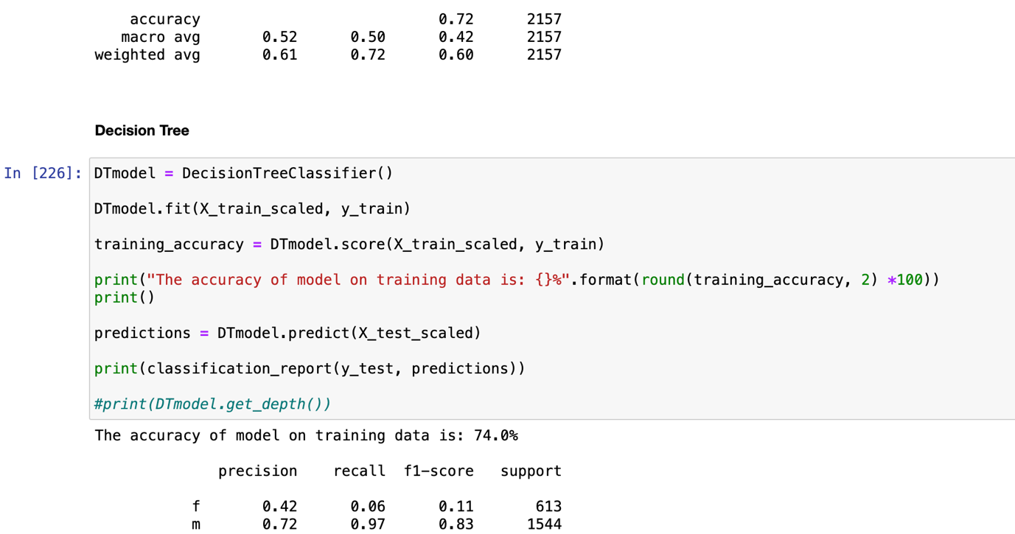



1. **Screenshots of each task of Activity 7**

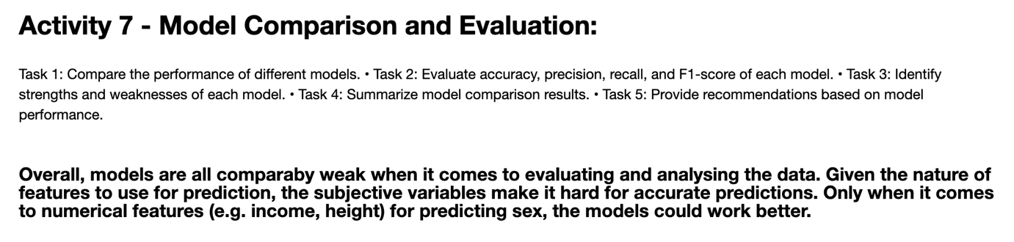

1. **Conclusions and Future Improvements**

**Conclusions:**

* Most of the users are between 25 to 35 years old.
* There are more male users than female users.
* Males are generally taller than females.
* (Activity 3) We cannot predict Zodiac signs using 'body_type', 'education', 'diet', 'orientation', 'pets', 'religion_cleaned', 'sex', 'job', 'smokes', 'drinks' and 'drugs' features.
* (Activity 4) We cannot predict body type by using lifestyle information ('diet', 'smokes', 'drinks', 'drugs'), sex and age.
* (Activity 5) We cannot predict the income of the user by making models based on their job, sex and education.
* (Activity 6) We can build good models with high accuracy(71-74%) to predict sex of an user with education level and income.
* However, an accurate model can be built to predict the gender of an user based on their height and body type. The accuracy is 85% with SVM, Logistic Regression, Decision Tree and KNN models.

**Further Improvements:**

The dataset, given its numerous categorical variables, is difficult to use for drawing strong correlations between its features. Hence, models made and predictions drawn are not strong. In the future, we can focus more on statistical or numerical features and draw correlations between them, or include less categorical features for analysis.

**Appendix**

a. 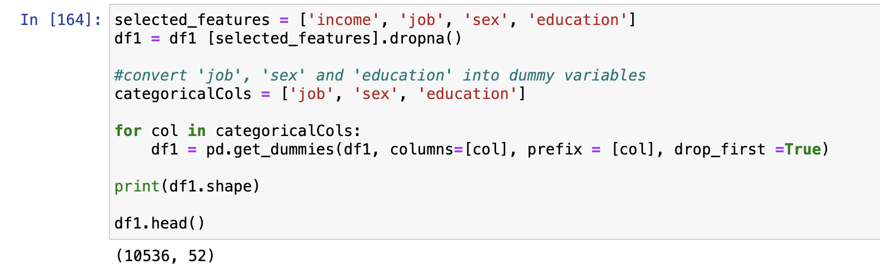

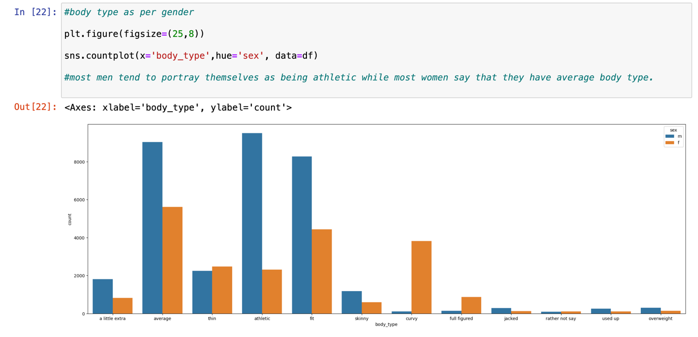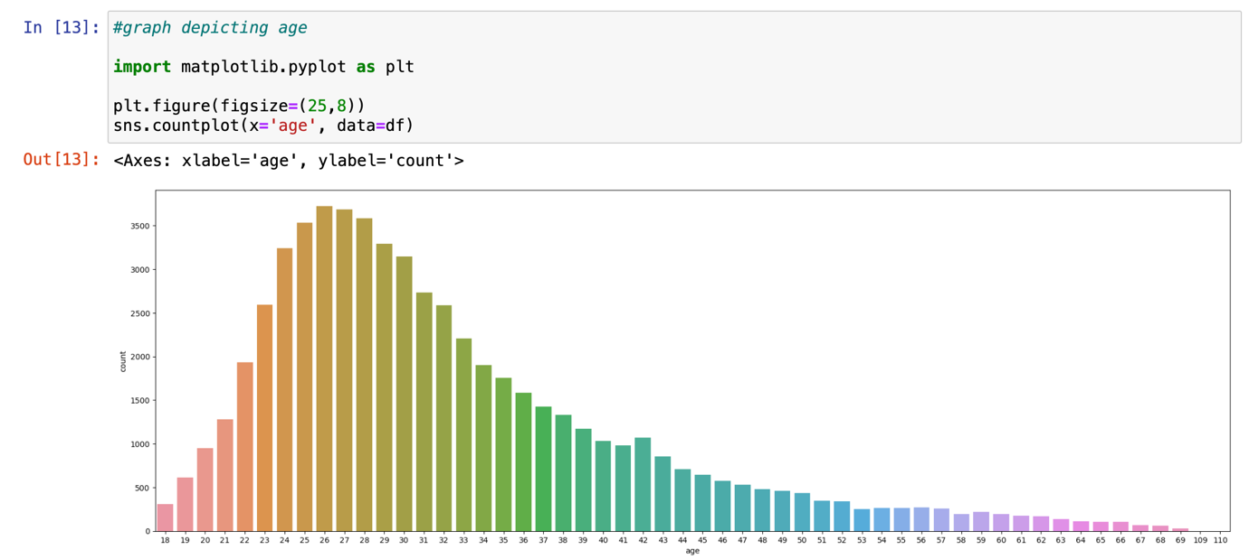b.